**The Power of Order of Operations (PEMDAS)**

**Why do we need an order for operations?**

Operations are actions you can perform on a number such as addition, subtraction, multiplication, division, etc. When there is only one operation it’s pretty straightforward. You can just perform the necessary algorithm to get the answer.

But what happens when there is an expression like this

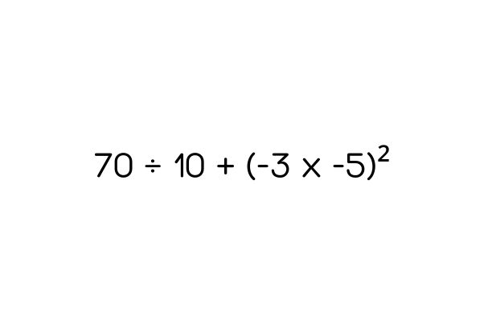

Which operation should we carry out first? We could start from the left and perform one by one. Or we could do the easy calculations first and then proceed. Does it even matter? The answer is yes it does matter. Depending on the order the operations are performed we would get different answers.

To maintain consistency in calculations the world of mathematics has a consensus regarding how we should prioritize operations. Let’s learn the standard rules that are established.

**PEMDAS**

PEMDAS is an acronym that makes it easier to remember the standard order of operations.

1. **P**arentheses: First, perform operations inside parentheses or other grouping symbols.
2. **E**xponents: Next, calculate exponents and roots.
3. **M**ultiplication and **D**ivision: Then, perform all multiplication and division from left to right.
4. **A**ddition and **S**ubtraction: Finally, perform all addition and subtraction from left to right.

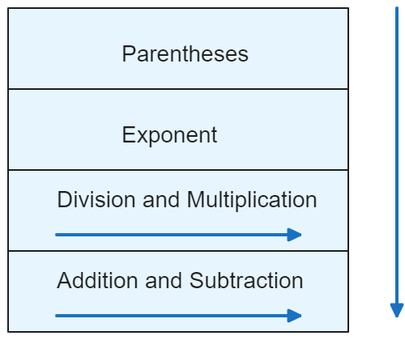

**Worked Examples**

Let us go through some examples to solidify our understanding of the PEMDAS principle.

**Example 1**

$10 + 5 × 3 - 6 ÷ 2$

Here, division and multiplication have a higher level than addition and subtraction. Therefore, the correct steps to follow are:

1. Perform multiplication and division from left to right.
$=10 + 5 × 3 - 6 ÷2$

$=10+15 - 6 ÷2=10 +15 - 3$

2. Perform addition and subtraction from left to right.

$= 25 - 3= 23$

**Example 2**

$(8 + 3) × (4 - 2)$

Since we have parenthesis in this equation, we have to prioritize the operations inside them first.

$=11×2$

Then we can perform the next available operation in PEMDAS order which is multiplication in this case.

$= 22$

**Example 3**

$24÷6 × 2$

In this expression, we can see the operations of division and multiplication. Since both of these operations have the **same precedence** we just perform the operations from **left to right.**

$=24÷6×2= 4 ×2= 8$

**Example four**

Let us now consider a more complex example that incorporates all of operations in the PEDMAS principle.

$\left(5+3×2\right)-{\left(8÷2-1\right)}^{2}$

First, we must evaluate the expressions inside the parentheses. Notice how there are multiple operations inside the parentheses. When evaluating operations inside the parenthesis, we must still follow the PEMDAS principle.

$=\left(5+3×2\right)-{\left(8÷2-1\right)}^{2}$

$= \left(5+6\right)- {\left(4-1\right)}^{2}$

$= 11 - 3^{2}$

The next step is to evaluate the exponents:

$= 11 - 9$

Finally, we can perform the subtraction to get the answer

$= 3$

**Conclusion**

The order of operations in mathematical calculations is crucial. You can verify its importance by redoing the examples in this article in different orders and observing how the results change. PEMDAS is the system we must follow to correctly evaluate calculations with multiple operations. You can use the mnemonic "Please Excuse My Dear Aunt Sally" to remember the order.